Planetary Best Health Care Insurance Company Incorporated (PBHCICI): Alien Age Analysis for Species on Boran and Radan

Olivia Samples

Lipscomb University, College of Computing and Technology

Abstract

Two new planets, Boran and Radan, have a preliminary healthcare dataset for their documented alien species. We have measured the life expectancy for each planet to better understand how our health care service can be marketed to them.

Introduction[1]

Planetary Best Health Care Insurance Company Incorporated (PBHCICI) provides healthcare to many species and are looking to expand to the recently discovered planets, Boran and Radan. Using a preliminary dataset, we compare each patient’s number of earth years of life and several medical diagnostics taken 6-months prior to the alien’s death. We hypothesize that one planet has better health than the other because each could not have had the same environment. The planet with the maximum age is Radan, so it was predicted to be the planet with better health. We chose two suitable tests to determine the overall health of each planet.

Methods

**Blood Pressure vs. Age:**

The first test used was to create a linear model comparing the patient’s blood pressure with the patient’s final age. After creating the proper schema to upload the data from all three csv files provided into one database, we queried the junction of the Boran data table and the Cross-Reference data table. We fitted a model where the dependent value was blood pressure and the independent value was the patient’s age. The same was done for Radan.

**Age Distribution:**

The second test analyzed each planet’s age distribution. Using matplotlib’s histogram plotting function, the patients for each planet were separated into 10 year increments. The average age for each planet was calculated, along with the probability of living longer than the average age.

**Validity:**

To ensure the consistency and validity of the database, the patient’s ID in the Cross-Reference Table was designated as the primary key. This key could connect to the foreign keys in the Boran and Radan table which were also named ‘patient_id’. In other words, it was impossible to add any records into the Boran and Radan table that did not have a matching ID in the set of primary keys. It was also impossible to delete any primary keys that were being referenced. This system was accurately tested, and so the database remained secure.

Results

**Age Distribution:**

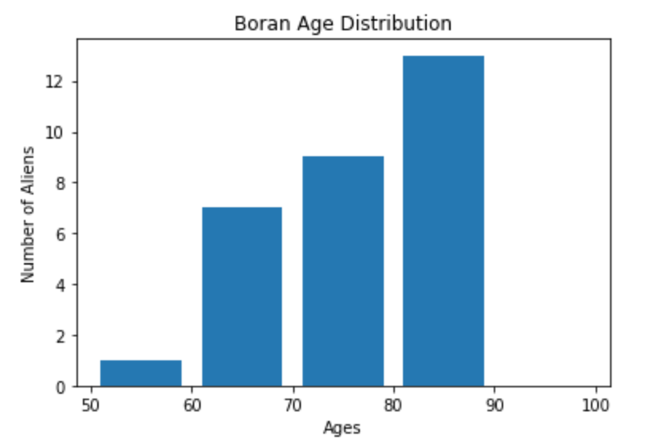The following histogram represents the age distribution for Boran.

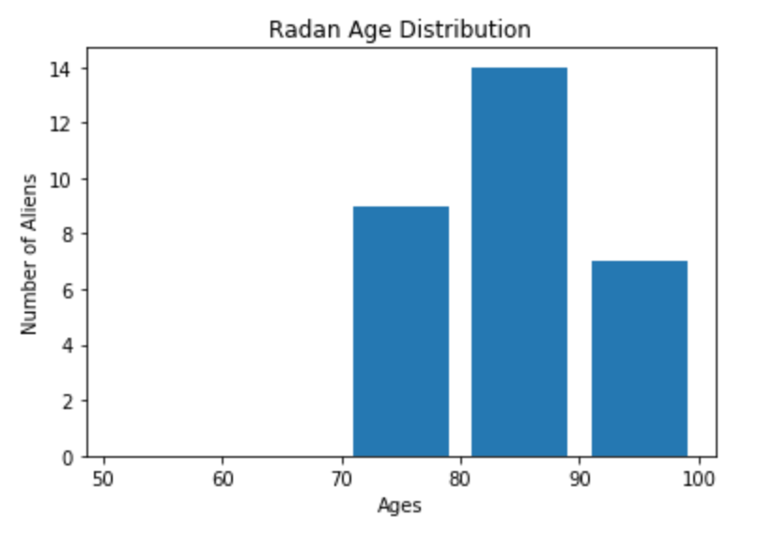The following histogram represents the age distribution for Radan.

Comparing these two charts, it is clear to see that there are more patients from Radan with longer life spans. In fact, the average life expectancy for Radan patients is 84.22 years, while it is 76.42 years for Boran.

**Blood Pressure vs. Age:**

The linear regression for the Boran data provided an intercept of approximately 106.457 mmHg* and a slope of 1.141 mmHg/year. In comparison, the linear regression for the Radan data provided an intercept of approximately 63.826 mmHg and a slope of 0.471 mmHg/year. Here, the slope can be thought of as the change in blood pressure versus the change in age. With a higher intercept, it is clear that Boran begins with higher blood pressure and it continues to increase as age increases at a faster rate than Radan.

Conclusion

Hence, through our analysis of this preliminary data set, we have shown that Boran patients tend to have higher blood pressure and a shorter life span than their Radan neighbors. The best application of these results for the benefit of PBHCICI would be to market more of the company’s resources towards Boran because it is in greater need of better healthcare.

While this analysis was thorough, further steps can be taken to improve the process and understanding of this data. For instance, there were many unused data points that affect a patient’s age such as: exercise, weight, glucose, and BMI. Further conclusions could be made when including these points within the linear regression models. Also, this data set was relatively small, so there will be more accurate results once the actual data set is approved and verified.

References

Planetary Best Health Care Insurance Company Incorporated (PBHCICI)’s Preliminary Data Sets

1. *mmHg is the unit of measure for blood pressure